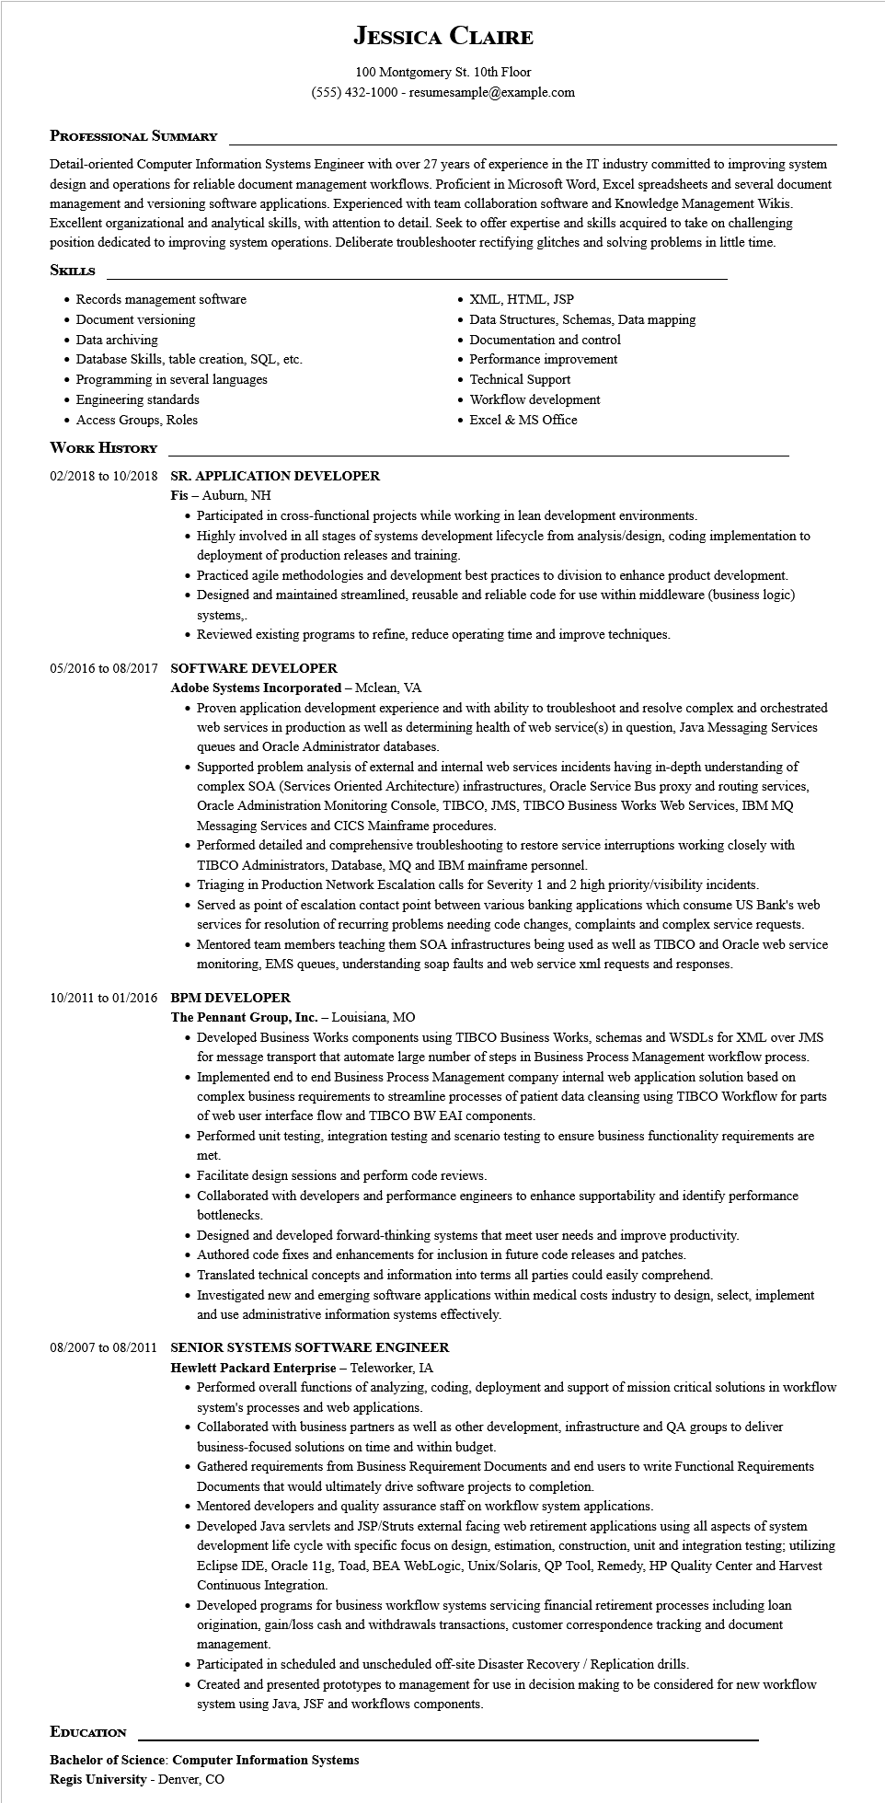
JESSICA CLAIRE
100 Montgomery St. 10th Floor
(555) 432-1000 - resumesample@example.com
PROFESSIONAL SUMMARY
Detail-oriented Computer Information Systems Engineer with over 27 years of experience in the IT industry committed to improving system design and operations for reliable document management workflows. Proficient in Microsoft Word, Excel spreadsheets and several document management and versioning software applications. Experienced with team collaboration software and Knowledge Management Wikis. Excellent organizational and analytical skills, with attention to detail. Seek to offer expertise and skills acquired to take on challenging position dedicated to improving system operations. Deliberate troubleshooter rectifying glitches and solving problems in little time. SKILLS
• Records management software
• Document versioning
• Data archiving
• Database Skills, table creation, SQL, etc.
• Programming in several languages
• Engineering standards
• Access Groups, Roles
WORK HISTORY
02/2018 to 10/2018 SR. APPLICATION DEVELOPER
Fis Auburn, NH
• XML, HTML, JSP
• Data Structures, Schemas, Data mapping
• Documentation and control
• Performance improvement
• Technical Support
• Workflow development
• Excel & MS Office
• Participated in cross-functional projects while working in lean development environments.
• Highly involved in all stages of systems development lifecycle from analysis/design, coding implementation to deployment of production releases and training.
• Practiced agile methodologies and development best practices to division to enhance product development.
• Designed and maintained streamlined, reusable and reliable code for use within middleware (business logic) systems,.
• Reviewed existing programs to refine, reduce operating time and improve techniques.
05/2016 to 08/2017 SOFTWARE DEVELOPER
Adobe Systems Incorporated - Mclean, VA
• Proven application development experience and with ability to troubleshoot and resolve complex and orchestrated web services in production as well as determining health of web service(s) in question, Java Messaging Services queues and Oracle Administrator databases.
• Supported problem analysis of external and internal web services incidents having in-depth understanding of complex SOA (Services Oriented Architecture) infrastructures, Oracle Service Bus proxy and routing services, Oracle Administration Monitoring Console, TIBCO, JMS, TIBCO Business Works Web Services, IBM MQ Messaging Services and CICS Mainframe procedures.
• Performed detailed and comprehensive troubleshooting to restore service interruptions working closely with TIBCO Administrators, Database, MQ and IBM mainframe personnel.
• Triaging in Production Network Escalation calls for Severity 1 and 2 high priority/visibility incidents.
• Served as point of escalation contact point between various banking applications which consume US Bank's web services for resolution of recurring problems needing code changes, complaints and complex service requests.
• Mentored team members teaching them SOA infrastructures being used as well as TIBCO and Oracle web service monitoring, EMS queues, understanding soap faults and web service xml requests and responses.
10/2011 to 01/2016 BPM DEVELOPER
The Pennant Group, Inc. - Louisiana, MO
• Developed Business Works components using TIBCO Business Works, schemas and WSDLs for XML over JMS for message transport that automate large number of steps in Business Process Management workflow process. • Implemented end to end Business Process Management company internal web application solution based on complex business requirements to streamline processes of patient data cleansing using TIBCO Workflow for parts of web user interface flow and TIBCO BW EAI components.
• Performed unit testing, integration testing and scenario testing to ensure business functionality requirements are
met.
• Facilitate design sessions and perform code reviews.
• Collaborated with developers and performance engineers to enhance supportability and identify performance bottlenecks.
• Designed and developed forward-thinking systems that meet user needs and improve productivity.
• Authored code fixes and enhancements for inclusion in future code releases and patches.
• Translated technical concepts and information into terms all parties could easily comprehend.
• Investigated new and emerging software applications within medical costs industry to design, select, implement and use administrative information systems effectively.
08/2007 to 08/2011 SENIOR SYSTEMS SOFTWARE ENGINEER
Hewlett Packard Enterprise - Teleworker, IA
• Performed overall functions of analyzing, coding, deployment and support of mission critical solutions in workflow system's processes and web applications.
• Collaborated with business partners as well as other development, infrastructure and QA groups to deliver business-focused solutions on time and within budget.
• Gathered requirements from Business Requirement Documents and end users to write Functional Requirements Documents that would ultimately drive software projects to completion.
• Mentored developers and quality assurance staff on workflow system applications.
• Developed Java servlets and JSP/Struts external facing web retirement applications using all aspects of system development life cycle with specific focus on design, estimation, construction, unit and integration testing; utilizing Eclipse IDE, Oracle 11g, Toad, BEA WebLogic, Unix/Solaris, QP Tool, Remedy, HP Quality Center and Harvest Continuous Integration.
• Developed programs for business workflow systems servicing financial retirement processes including loan origination, gain/loss cash and withdrawals transactions, customer correspondence tracking and document management.
• Participated in scheduled and unscheduled off-site Disaster Recovery / Replication drills.
• Created and presented prototypes to management for use in decision making to be considered for new workflow system using Java, JSF and workflows components.
EDUCATION
Bachelor of Science: Computer Information Systems
Regis University - Denver, CO

